Java 17

List of software’s required

1. JDK 17
2. Eclipse IDE

Java - platform independent and object oriented programming language

Customer - getDetails(), withdraw(), deposit()

Account - getBalance(), credit(), debit()

Two main building blocks of an object oriented language

1. class - template for an object
2. object - instance of a class

Java Fundamentals

* Datatypes & Variables
* Arrays
* Operators
* Conditional Statements
* Loops
* Classes & Objects

A class can have

1. variables
2. methods
3. constructors

Constructors: These names must be same as the class name, they are called when object is created, by default compiler creates a default constructor in case the class doesn’t have any explicit constructor, however if the class have any explicit constructor then compiler doesn’t create any constructor

OOPs principles

1. Inheritance - extends
2. Encapsulation - private data & public methods
3. Polymorphism - overloading & overriding
4. Abstraction - interface & abstract class

Day 2

* Inner classes - local, anonymous, nested, static inner classes
* Java 8 features - functional interface, lambda expression, default & static methods
* Packages & Access Specifiers like private, public, protected & no access specifier
* Factory design pattern to write a loosely coupled code
* Identify & Create the necessary java classes for your project (no need to create DB / Business logics right now) - create a separate java project for this

Day 3

* Go through the TOC and try to cover all the topics that are in Day 3 & Day 4
* Important topics to cover that helps to solve the case study are below
* Exception Handling
* String processing
* Collection Framework
* Comparable & Comparator
* Map
* Using Collections with streams and applying lambda expressions

Note: Currently you can’t use DAO layer to interact with the Database, however collection acts like an in-memory database -> because it allows you to add/update/delete/read java objects

Collection Framework:

It provides all kinds of methods to maintain the data, its size is dynamic in nature

In Collection Framework there is a root interface called Collection

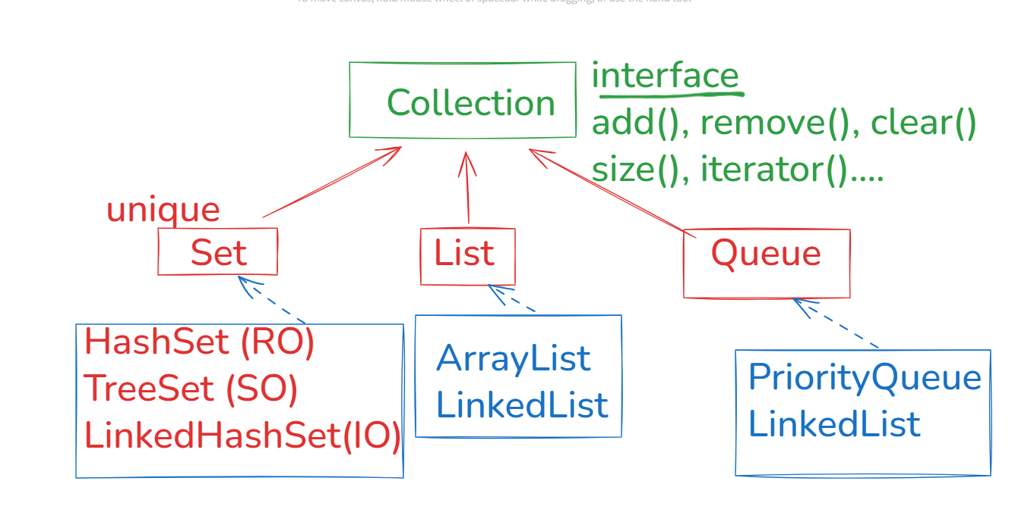

Queue -> Concentrates on processing the data while removing -> FIFO (LinkedList) -> Queue provides a method poll() to remove the element

PriorityQueue-> Removes the elements in sorted order